Student Name:_______________________

 | Eastern Goldfields College  Mathematics Applications U3&4 2017  Investigation 2
Working Time: 55 minutes | CALCULATORS ARE ALLOWED Total Marks: 50

COMPETITION

In this investigation, networks and matrices will be used to represent competition between teams and players. Use the letters provided to represent the nodes.

Question 1 (10 marks: 2, 2, 2, 2, 2)

Team A has three players:  - Kyle (K),  - Rod (R) and  - Ahmed (A) | Team B has three players:  - Stefan (S),  - John (J) and  - Nigel (N)

Each person in Team A plays a match against each person in Team B.

These nine matches can be represented by a bipartite graph in which the members of Team A form one set of nodes and the members of Team B form another set of nodes. There is an edge drawn from each member of Team A to each member of Team B.

- Draw the bipartitie graph described above. [2]

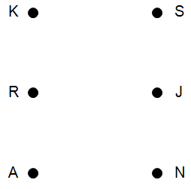

- The adjacency matrix for this non-directed network is given below. [2]
Describe what the elements of the adjacency matrix represent.
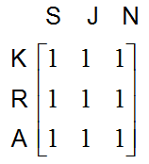

- Team C has four players: Lou (L); Nat (N); Trish (T); and Ali (A).
Team D has four players: Di (D); Indi (I); Jane (J); and Pat (P)
Each person in Team C plays a match against each person in Team D.

Represent the matches between the two teams as
(i) A bipartite graph [2]

(ii) An adjacency matrix [2]

- For two teams of n players in each team where each person in the first team plays a match against each player in the second team, describe the adjacency matrix. [2]

Question 2 (12 marks: 1, 1, 2, 2, 4, 2)
An extra person has joined Teams C and D.
Team C now has five players: Lou (L), Nat (N), Trish (T), Ali (A) and Barb (B).
Team D now has five players: Di (D), Indi (I), Jane (J), Pat (P) and Kath (K).
Each person from each team plays three matches against three players from the other team and these are represented by a ✓ in the table below.
 | L | N | T | A | B
D | ✓ | ✓ | ✓
I |  |  | ✓ | ✓ | ✓
J | ✓ |  |  | ✓ | ✓
P |  | ✓ | ✓ |  | ✓
K | ✓ | ✓ |  | ✓

(a) Name the people that Jane plays. [1]

(b) How many matches altogether? [1]

(c) Use a bipartitie graph to represent the matches played between the two teams. [2]
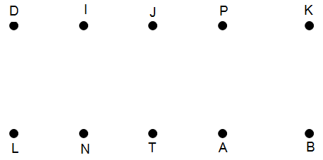
- The complement of this graph is the graph where the edges all represent the matches that were NOT played between the two players at each node. Draw the complement described. [2]

- Determine the adjacency matrix for: [4]
(i) the played matches in part (c) | (ii) the matches which were not played in part (d)

- Describe the matrix formed by adding the two matrices from part (e). [2]

Question 3 (8 marks: 1, 1, 1, 1, 3, 1)
Three more players have joined the A and B teams. The new teams are as follows:
Team A: Kyle (K), Rod (R), Ahmed (A), Barry (B), Dong (D) and Terry (T)
Team B: Stefan (S), John (J), Nigel (N), Fraser (F), Chas (C) and Peter (P)
Each person in Team A is scheduled to play each person in Team B. Some matches have already been played. The adjacency matrix of the complement of the graph for all matches played is provided below.
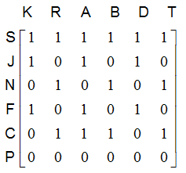
- On the graph represented by this matrix, how many edges will connect Chas to Team A players? [1]

- How many edges in total will there be on the graph represented by the matrix given? [1]

- How can you use the elements of the matrix to determine the answer to part (b)? [1]

- Which players has John already played? [1]

- Which player has not played any matches? Justify your answer. [3]

- Which node on the bipartite graph of matches played will be unconnected from the network? [1]

For Questions 4 and 5, winning and losing matches will be considered and the graphs will be digraphs.
Question 4 (9 marks: 2, 1, 1, 3, 2)
The digraph below represents the matches played between members of Team A and members of Team B. No connection indicates a match has not been played and a win is represented by .
Example F G indicates F beats G and G loses to F

Team A: Kyle (K), Rod (R), Ahmed (A), Barry (B), Dong (D) and Terry (T)
Team B: Stefan (S), John (J), Nigel (N), Fraser (F), Chas (C) and Peter (P)
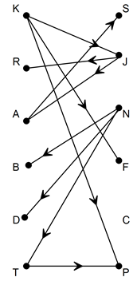
- The graph is bipartite. Explain. [2]

- Which player has not played any matches? ______________________________ [1]
- How many matches have been played? ______________________________ [1]
- Which players have:

  - won every match they have played? [1]

  - lost every match they have played? [2]

- Describe two of the features of the adjacency matrix for this network. [2]

Question 5 (11 marks: 1, 1, 2, 2, 2, 1, 2)
Team E has five players: Lily (L), Nora (N), Tricia (T), Alison (A) and Deirdre (D).
They need to determine a playing order so they play each other. The results of these matches are given in the table below.
 | L | N | T | A | D
L beats | - | ✓ | ✓ | X | ✓
N beats | X | - | ✓ | ✓ | ✓
T beats | X | X | - | ✓ | ✓
A beats | ✓ | X | X | - | ✓
D beats | X | X | X | X | -

- Who wins the most matches? ______________________________ [1]
- Who loses the most matches? ______________________________ [1]

- Use a digraph to represent this information. [2]

- Is the digraph drawn in part (c) bipartite? Justify your conclusion. [2]

- Determine the adjacency matrix for the digraph. [2]

- Explain the nature of the elements along the leading diagonal. [1]

- Describe and explain the symmetry of the adjacency matrix about the leading diagonal. [2]

~ END OF INVESTIGATION ~

